June 2018 PIT Group Report – Project PS17002
WINTER SESSIONS

PISTACHIO APPC INFORMATION and R&D PRESENTATIONS

June 2018 - Meeting Dates and Venues

Riverland: Wednesday 27th of June, 12 Noon sharp
Address: East Meeting Room, PIRSA Loxton Research Centre, 1801 Bookpurnong Road, Loxton, SA, 5333

Sunraysia: Thursday 28th of June, 12 Noon sharp
Address: Banksia Room, AgVic Mildura Centre, DEDJTR, Corner Eleventh St and Koorlong Ave, Irymple, VIC, 3498
TOPICS:
- Getting to know your APPC benchmark data – Chris Joyce
- Pests and Disease management – orchard sanitation
    - Carpohilus beetle – Dr Cathy Taylor
    - Carob Moth – Blair Grossman
- Winter pruning – Ben Thomas
- Navigating the Pistachio website – Craig Feutrill
Riverland: 18 growers attended as well as speakers, Craig Feutrill, Chris Joyce, Ben Thomas, Cathy Taylor and Blair Grossman. Chris Joyce delivered an update on the new APPC benchmarking data and how it relates to each grower’s business. Ben Thomas gave an insight into winter pruning of mature pistachio trees and the various methods used by farms in Australia and overseas. This as a precursor to next month’s PIT Group which will be held on-farm giving demonstrations of pruning.
Cathy Taylor and Blair Grossman gave an enlightening (and frightening) talk on the damage Carpophilus beetle and Carob moth are causing in Almond orchards in the Riverland and Sunraysia and the need for exceptional levels of orchard sanitation to minimise damage from these two pests (the insects not the speakers). Craig Feutrill gave an online demonstration of the PITGroup section of the PGAI website, including Videos, all meeting information and the Production Puzzle.

Sunraysia: 8 Growers attended with the same speaker list/presentations as above.

After the meetings in the Riverland and Sunraysia a few growers were asked to participate in feedback reporting of which the major outcome was the need for field demonstrations in each growing region of the pruning techniques for young (central leader) and mature trees.

Pictures overleaf

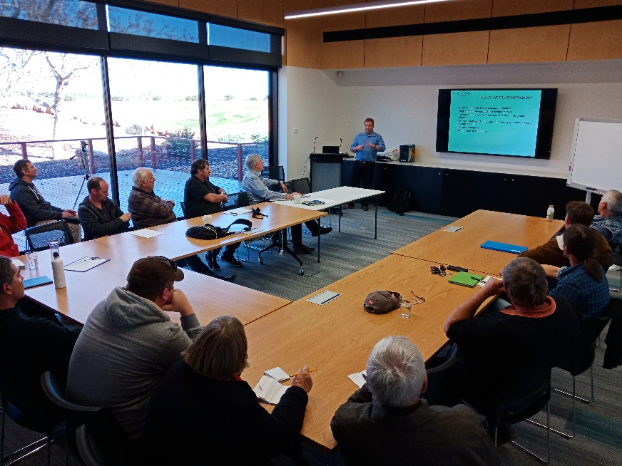
Ben Thomas describing winter pruning of mature pistachio trees.

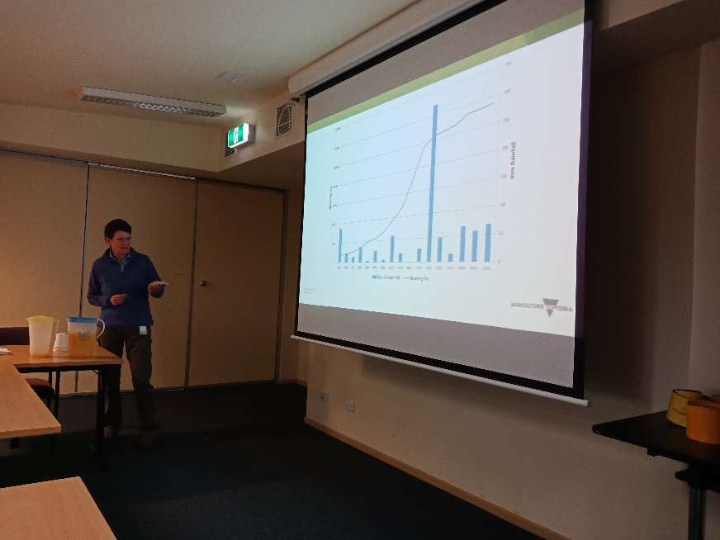

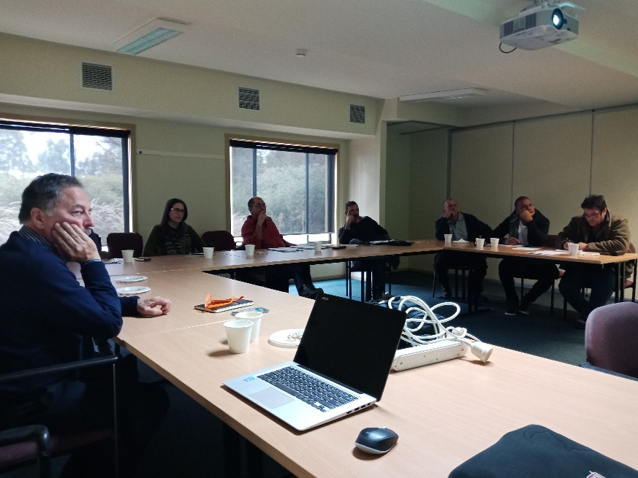
Dr Cathy Taylor discussing Carpophilus beetle damage in almond orchards and the need for sanitation to minimise effects.

Chris Joyce and growers at the Sunraysia meeting.

